**CHAPTER 3 FAN**

The fan is the machine that delivers the gas, generally divided into three categories, namely, fans, blowers and air compressors. What use mostly in nuclear power plant are fans, which are used to provide air transmission power for the ventilation and air conditioning system of each plant and different working areas. For example, a 1000MW PWR nuclear power plant, ventilation, air conditioning system, about 40, of which nuclear ventilation and air conditioning of the nuclear island and nuclear auxiliary plant account for more than half. Nuclear ventilation, air conditioning are not only to create a comfortable working environment for the nuclear power plant, but more importantly is to meet the protection requirements of protecting staffs' health from radiation ; some nuclear ventilation system and nuclear safety is directly related. Therefore, understanding and mastering the performance of the fan, the major structure, use and operating conditions is the basic requirements to ensure the safe operation of the fan. This chapter will focus on the introduction of the fan.

**3.1 BASIC THEORY OF THE FAN**

**3.1.1 The working principle and theoretical equation of the 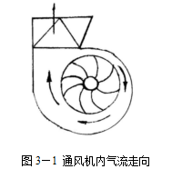fan**

1. The working principle of the fan

The working principle of the fan is the same as centrifugal pump, it relies on the rotation of the impeller, and so that the gas obtains energy, thereby enhancing the pressure and speed, achieving the purpose of conveying gas.

The flow of gas in the centrifugal fan is shown in Figure 3-1.

**Figure 3-1 Air Flow Direction in the Fan**

1. The theoretical equation of the fan

The theoretical equation of the centrifugal fan is also bases on the velocity triangle and derived from the theorem of moment of momentum. For the fan is a single-stage pump, of which the gas compression capacity is not big, we can think that the inlet and outlet gas density is equal, thereby its theoretical equation is exactly identical with the centrifugal pump. So the centrifugal fan also has the theoretical characteristics of centrifugal pumps. The axial fan’s principle is the same as the axial water pump, and also conforms to the theoretical equation of the centrifugal fan and follows the wing theory. Its design and manufacture are mainly based on wing theory.

1. Fan blades

(1)Ventilator blade form

According to the theoretical equation of the fan and the triangle principle of impeller speed, the fan blades also have three forms, namely:

1. When the flow angle β2> 90 ° ,it's the forward curved blade, as shown in Figure 3-2(a);
2. When the flow angle β2 <90 ° ,it's the backward curved blade, as shown in Figure 3-2 (b);
3. When the flow angle β2 = 90 °, it's the radial blade, as shown in Figure 3-2 (c).

(2) Comparison of three blade forms

1. Forward curved blade :the largest wind pressure, the smallest leaves, the worst efficiency, adapted to the wind pressure which requires high requirements, while the speed (n) and the impeller diameter (D) are limited to the working conditions to some extent;
2. Backward curved blade :the highest efficiency, the largest blade, the lowest wind pressure, adapted to high-power fan;
3. Radial blade: wind pressure, blade and efficiency are at the middle level among these three types, but the blade processing and manufacturing is simple, easy to fouling and wear, so the moderate and low pressure fan tend to use radial blades.

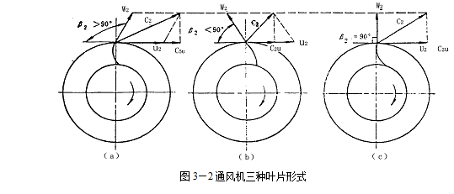

**Figure 3-1 Three Types of Blades for the Fan**

* + 1. **Similarity principle and similarity-transformation of the fan**